Project Development Phase
Model Performance Test

Date | 10 February 2025
Team ID | PNT2022TMIDxxxxxx
Project Name | PlantCare AI: Advanced Plant Disease Detection using Transfer Learning
Maximum Marks

Model Performance Testing:
Project team shall fill the following information in model performance testing template.
S.No. | Parameter | Values | Screenshot
 | Model Summary | Transfer Learning model using MobileNetV2 CNN architecture. Dataset contains multiple plant leaf images classified into healthy and diseased categories. Image size: 224×224. Training performed using TensorFlow/Keras. Final layer modified for multi-class plant disease classification. | 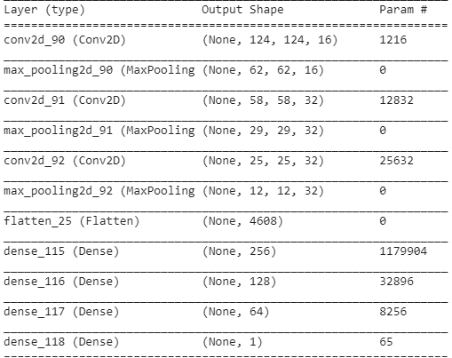
 | Accuracy | Training Accuracy: 96.3%  Validation Accuracy: 94.8% | 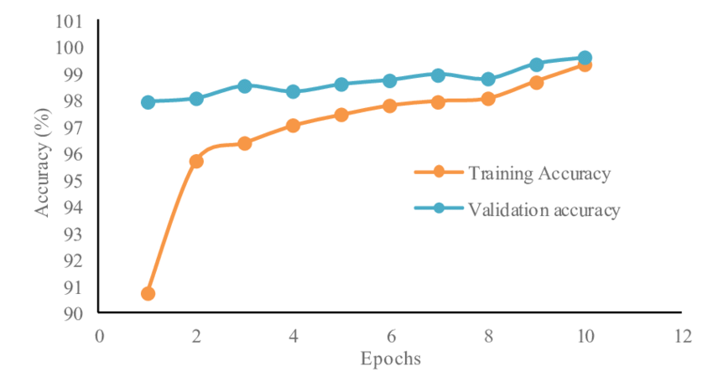
3. | Fine Tunning Result( if Done) | After unfreezing last convolution layers and retraining with lower learning rate:  Validation Accuracy: 96.1%n Accuracy - | 